**MANUAL OF INGA AGROFORESTRY**

**By Guillermo Valle**

**INTRODUCTION**

In general, smallholder farmers on slopes face many problems. They have to make a living on landscapes of 30 % or more of incline, with shallow soils, rampant deforestation (due to slash and burn agriculture), high risk of erosion and landslides, loss of biodiversity and water, as well as using an agricultural system that is highly extractive and ends in soil degradation.

The genus Inga is inclusive of around 300 species, which are widely distributed, and very commonplace in low and highland areas of tropical America. Some species have over 2000m of altitudinal range while others can tolerate a very wet climate with 3500-5000 mm of rain per year or a seasonal climate with a 5-6 month dry period and very low rainfall (Pennington and Fernandes, 19987).

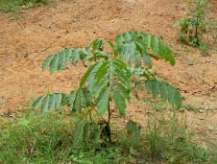

Throughout history, pre-Colombian Indians have used Inga as an edible fruit, the sweet cottony cover of the seed being edible, and recently as a shade tree for cocoa, coffee and tea. More recently, Hands (19984) has used Inga in an alley-cropping scheme where its rapid germination and growth, tolerance of poor soils, its nitrogen fixation and mycorrhizal activity, as well as a great ability to coppice and control weeds made it a great multipurpose tree to use in agroforestry in combination with a wide array of sustenance and cash crops.

*Young Inga edulis. Photo © Tiiu Miller 2009*

The Inga species used in alley-cropping must be tolerant of repetitive pruning at 1.5 m height as well as producing abundant branching that can provide sufficient foliage to allow a permanent mulch cover on the ground. This mulch supplies nutrients, controls weeds, prevents erosion and conserves water. The most outstanding species have turned out to be I. edulis, I. oerstediana and I. vera (Hands, 19984; CATIE, 20033).

Alley cropping is a technology with great flexibility, designed to improve and maintain soil fertility, improve crop productivity and/or lack of animal forage, providing at the same time wood for energy and construction. It involves leguminous trees grown in hedgerows, interplanted with food or forage crops between the rows. Pruning provides foliage for mulch or fodder, and wood for fuel or timber. Alley cropping can also prevent erosion and the mulch prevents water evaporation (Reynolds and Jabber, 19948).

Inga alley-cropping is a combination of technologies of soil, water, nutrients, and vegetation management based on the use of crops, their residues and shrubs in a spatial arrangement with Inga trees planted in contour on slopes.

**INGA POTENTIAL FOR AGROFORESTRY**

Inga is used as a shade tree traditionally in coffee plantations where it is recommended to mix it with high commercial value trees such as Cordia alliodora, Cedrela odorata, Swietenia macrophylla, Cordia megalantha, Swietenia humilis or Dalbergia glomerata. All these trees have good growth rates and ample uses and they should progressively replace Inga as shade.

A more complex scheme involves associating coffee, plantain, Inga and Cordia. The plantain serves as shade for the first two years as well as financing part of the costs while Inga takes over as shade after the third year, and the fast growing Cordia will take over as permanent shade after a few years. The yield of coffee with fine wood species has been found to be 520, 780 and 1300 kg/ha in years 3, 4 and 5, respectively (CATIE,20033).

Another agroforestry system is that recommended by the Honduras Foundation for Agricultural Research (FHIA, in Spanish) for cocoa with yucca and Inga. The yucca provides temporary shade for the cocoa as well as income and food for the first year, while Inga takes over as permanent shade, producing fuel wood and mulch from prunings. Yields of cocoa associated with Inga can be of 130 kg in the second year, increasing progressively up to 1000 kg/ha in year eight.

So far, all known species of Inga produce root nodules that contain nitrogen-fixing bacteria and Inga roots associate with mycorrhizal fungi. The nitrogen fixation provides mulch with high nitrogen content as well as other nutrients, and the mycorrhizal associations probably allow the Inga plant to be able to recycle phosphorus, one of the major limiting nutrients in the tropical rainforest ecosystem. The slowly decomposing permanent leaf mulch provides a sustained release of nutrients and also has the effect of causing roots to remain in the top soil layer right below the mulch. This is similar to what happens in natural forests and the mulch has other effects such as lowering soil temperature, which allows crop seeds to germinate, as well as conservation of humidity and protection against erosion (Pennington and Fernandes, 19987; CATIE,20033). It has been demonstrated by Herrera et al., (19935) that effective associations between leguminous trees and mycorrhizal fungi significantly improve growth and nitrogen fixation in relation to non-mycorrhizal plants in tropical phosphorus deficient soils. Fernandes et al.,(Pennington & Fernandes, eds., 1998,Ch.47) have shown that the growth effect of inoculation with mycorrhizae was equivalent to the addition of 30 kg P/ha.

One of the most common crops of smallholder farmers is corn, which requires, depending on the soil, around 80 kilograms of nitrogen, 18 of phosphorus, 66 of potassium, 15 of calcium and 10 kilograms of magnesium per hectare. In one study, Inga edulis provided 124 kilograms per hectare of nitrogen, 5 of phosphorus, 57 of potassium, 13 of calcium and 12 of magnesium. The only limiting nutrient here would be phosphorus. Another study showed that Inga oerstediana could provide up to 28 kilograms per hectare of phosphorus while Inga edulis provided up to 41 kilograms. In this second study it could have happened that mycorrhizal fungi associated with Inga roots and where helping the plant assimilate more phosphorus.

Mahogany trees planted alone or in association with Inga edulis and Inga ilta had a survival rate of 84, 93 and 89 %, respectively, while the respective percentage of attack by the Hypsipylla borer was 46, 33 and 33 %.

All the attributes of the Inga species in alley-cropping schemes show that this multi-purpose tree can recycle nutrients by its decomposing mulch, reduce erosion and conserve soil humidity, control pests as well as weeds and thus increase productivity of degraded soils in the tropics.

Intensive fertilization in the tropics is criticized as unsustainable in nutrient cycling because extreme rainfall intensities may cause high nutrient losses by leaching and runoff (Horst, 19925). Fertilizer phosphorus may be lost by fixation to aluminum and iron oxides in the soil (Balligar and Bennett, 19862). Alley cropping with perennial nitrogen fixing trees is expected to reduce leaching losses by increasing soil organic matter and hence nutrient buffer capacity and by continuous nutrient uptake by trees (Akonde et el., 19971).

Alley-cropping is an appealing option for sequestering carbon on agricultural lands because of its capability to sequester considerable amounts of carbon while leaving the bulk of the land in agricultural production, thus contributing to reduce climate change (Schoeneberger, 20099).

**MANAGEMENT OF INGA ALLEY CROPPING**

**Seeding and Nurseries**

In the lowland plains of the north coast of Honduras seed production occurs in June, after a short dry period of 4 to 6 weeks, but the largest seed crop happens in September with Inga edulis, one of the better species for alley-cropping. Collection is done by hand and the long pods are opened manually and the seeds separated from the cottony sweet pulp to avoid itsfermentation. Seeds are not dried and should be planted in the following 2-3 days after separation from the pulp, because its germination capability is very low after a week. It is recommended that the seeds be submerged for 12 hours in a water solution containing macerated adult Inga root nodules and soil from under these trees. However, Inga is a non-specific nodulator, which means most soils. contain nitrogen-fixing bacteria that will nodulate on Inga root.

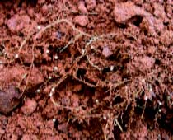

*Inga root nodules. Photo ©Gaston Bityo Delor 2010*

Once the plants are ready, whether 30-40 cm high or after 3 months in the bag, they should be taken to the planting site during the rainy season, to assure wet soils which augment the possibility of the plants to take root. If on a slope, a makeshift wood A frame levelling instrument will be needed to make sure the planting will be in contour. The distance between rows of plants normally is 4 meters and between plants in a row, 50 to 100 centimetres. If the latter distance is chosen, but

l

**Establishment and Growth**

*Inga seeds germinating in black plastic bags, and young Inga seedlings in the bags. Photo © Guillermo Valle 2010*

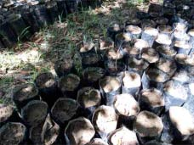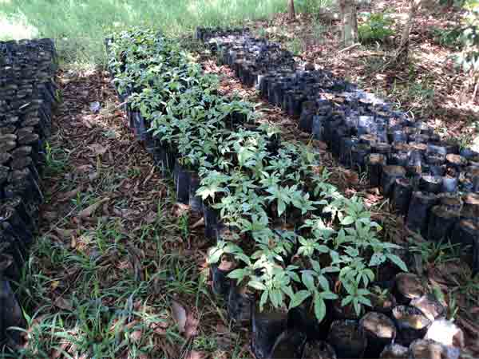

*Cleaning the seeds by removing the pulp. Photo © Guillermo Valle 2010*

The best method of propagation is using plastic bags 15 cm wide and 20 cm high, filled with soil. If enough seed is available, two should be planted in each bag, eliminating the smaller of the two in case both germinate. Bags should be placed under shade with periodic watering to maintain the soil humidity. Germination will occur in 1-2 weeks. The plants will be ready for the definitive transplant when 30-40 cm high after around 3-4 months. During this period, shade must be progressively eliminated.

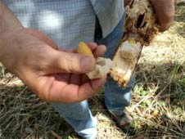

*Collecting the seeds, and ripe Inga seeds. Photo © Guillermo Valle2010*

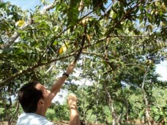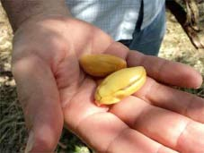

*Rows of Inga at FunaVid with a wider spacing and pineapples planted in between to halt erosion. Photo © Tiiu Miller*

*Rows of Inga growing on either side of the alley. Photo © Guillermo Valle*

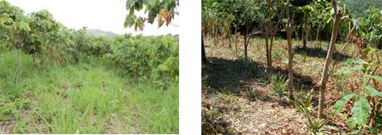

later it will be necessary to plant a crop such as pineapple between each tree in the row to help control erosion. If the distance is 50cm, then it will suffice to place the thin branches not used as fuel wood in the spaces between trees to help hold any soil, which might be eroded, by rains. During the first year it will be necessary to clear vegetation 3-4 times at least. If the vegetation is not so thick, than clearing 1 meter around each plant will do. However, if vegetation is thick, then clearing the whole area will have to be done. These clearings must be done until the Inga canopy closes and starts to smother weeds and other vegetation. This should happen in the second year. However in some degraded slopes this process can take up to 3 years.

**Intercropping**

Once the canopy has closed, it will need to be pruned for crops to be planted. The trees are pruned to about chest height. Pruning too low could kill the trees. Once the pruning is done, sunlight will be available for crops to grow and all foliage will be deposited in the ground between rows. However, in degraded soils where Inga needs more time to grow, crops can be planted even during the first year when no pruning is needed, but foliage from legumes will have to be applied as mulch to decompose so its nutrients are available for the crop. Such legumes could be Cassia siamea, Acacia mangium, Gliricidia sepium or any other plants know to the locals.

*Inga alley with closed canopy (Photo © Tiiu Miller 2009), and pruned Inga (Photo © FUPNAPIB 2006), letting in the light so that the crops can be planted between the rows of Inga.*



Crops such as corn can be interplanted within rows (normally 4 meters wide) at 1 meter between crop rows for a total of three rows of corn in the alleys. Beans can be planted up to five rows in each Inga alley, while three rows of pineapples will grow well. Spices such as black pepper can also be grown within the Inga alleys. Live stakes (tutors) for support of the pepper plants will be needed and should be planted in one row in the alleys at 2 meters separation between tutors.

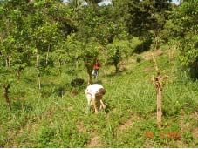

*Beans growing in Inga alley. Photo © Guillermo Valle 2009*



*Pineapples growing in Inga alleys. Note the Inga re-growing on the sides. Photo © Guillermo Valle 2009*

*Honduran farmer in tall maize grown*

*with Inga. Photo© Antony Melville 2007*

Once the Inga has been pruned, it will take from 8 to 12 months before it completely closes again, allowing at least 6 months of sunlight for the crops. This will depend on the soil and climate.

In Honduras, once corn is ready to harvest, it is very common for the smallholder farmer to bend the stalk because he is usually short of labor and it is in the rainy season and he cannot harvest in one day, so this helps avoid the corn catching water and rotting because the husks will shed rainwater.

**IMPLICATIONS OF INGA ALLEY CROPPING**

In relation to food security, Inga alley-cropping replaces unsustainable slash and burn agriculture, resists droughts of up to six weeks, decreases erosion and landslides, increases productivity and generates more than 100 % of the fuel wood the farmer needs for cooking from a not very big plot.

Economically, Inga alley cropping increases the return rate on investment, minimizes use of external expensive chemical inputs, liberates land for diversification and competes favorably with imported grains.

As far as labor is concerned, Inga alley cropping reduces total days of labor, increases efficiency and productivity of the land and reduces or eliminates weeding.

The environment is favored with Inga alley cropping because it increases water retention in the soil and quality of the same, reestablishes wild life, and regenerates recycling processes and natural associations. And where forest is being continuously cleared for new fertile plots to farm this is no longer necessary as the Inga enables the same plot to be farmed continuously year after year.

**Characteristics of Inga Alley cropping**

It is an agroforestry prototype resulting from the combination of local and scientific knowledge.

It starts with zero burns.

It is based on the concept of soil improvement.

Soil has direct cover from crop residues and biomass from prunings.

Middle strata are covered with crops.

Arboreal cover in top strata by Inga planted in contour at 4 meters between rows.

More than 12 years of persistency to this date.

Protects and recovers biodiversity.

Allows animal use when crop residues provided or forages planted.

Provides fuel wood for home use and surplus for sale.

It is an open system that accepts improvement.

**Lessons Learned**

Without food security there is no opening towards resource management and diversification.

Participatory processes are an effective way to assure success with any new technology.

Zero burning generates demand for new technologic menus.

Emphasis on adequate soil management makes this system successful.

**What do Producers Say?**

Reduces labor, cost and time while increasing productivity.

Maintains soil humidity, reducing losses from drought for up to six weeks.

Produces enough fuel wood.

One farmer can manage up to 2.0 hectares.

Allows diversification.

**BIBLIOGRAPHY**

1. Akonde, T.P., Kuhne, R.F., Steinmuller, N, and Leihner, D.E.  1997   Alleycropping in an Ultisol in sub-humid Benin. Part 3: Nutrient budget of maize, cassava and trees.  Agroforestry  Systems  27: 213-226
2. (Balligar and Bennett, 1986)
3. CATIE, OXFORD FORESTRY INSTITUTE & FORESTRY RESEARCH PROGRAM.  2003  Arboles de Centro America. CATIE, Turrialba, Costa Rica.
4. Hands, M.R.  1998  The uses of Inga in acids soils of the rainforest zone: alleycropping sustainability and soil regeneration. IN: The genus Inga: Utilization.  Pennington, T.D. & Fernandes, E.C. (eds). pp 53-86
5. Herrera, M.A., Salamanca, J. and Barea, J.M.  1993  Mycorrhizal associations and their functions in nodulating nitrogen-fixing trees. In: Subba, N.S. and Rodriguez, C. (eds) Symbiosis in nitrogen-fixing trees.  Oxford and IBH Publishing Co. New Delhi, India. pp 141-158
6. Horst, W.J., Asher, C.J., Szulkiewicz, P., and Wiesemeier, A.  1992  Short term responses of soybean roots to aluminum. J. Plant Physiol.  140: 174-178
7. Pennington, T.D. and Fernandes, E.C.  (eds)  1998  The genus Inga: Utilization. Continental Printing, Belgium. 167 p.
8. Reynolds L. and Jabber, M.  1994  The role of alley farming in African livestock production.  Outlook on Agriculture  23 (2):  105
9. Schoeneberger, M.  2009  Agroforestry working trees for sequestering carbon on agricultural lands.  Agroforestry Systems  75: 25-37

Copyright © Guillermo Valle 2010. It is permissible to copy any, or all, of this publication for non-commercial scientific or educational purposes provided credit is given to Dr. Guillermo Valle, CURLA, Honduras.

Inga alley cropping is based on the original work of M.R. Hands, Cambridge University, UK