STEP BY STEP GUIDE FOR INGA ALLEY CROPPING
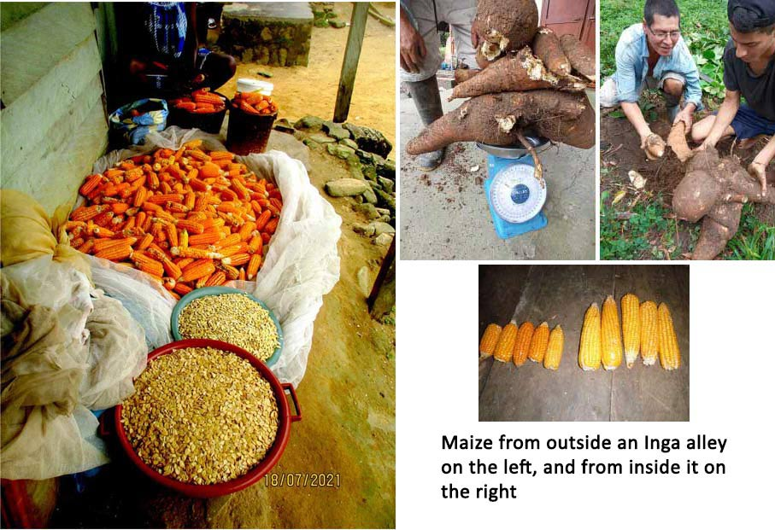

By Rainforest Saver SCIO
www.rainforestsaver.org Charity no. SC050373

Inga alley cropping is based on the power of legumes to fix nitrogen from the air, thus fertilising the soil by making nitrogen available to plants. Inga edulis is a legume tree. Rows of it are planted, with spacing of half a metre to a metre between the trees, and spaces, the alleys, of 4 to 5 m between the rows. The trees grow and close their canopies across the alleys. Lack of light kills the weeds in the alleys. The inga are then pruned, letting light into the alleys. The bigger branches are useful firewood for cooking. The rest is left to rot down to a fertile mulch in the alleys. The crops are planted into this. The crops grow well, are harvested, and the trees regrow. The cycle is repeated year on year.
Some great produce from Inga alleys

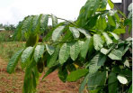

- Under what conditions is Inga alley cropping suitable?
It is suitable in tropical climates, like rainforest areas, where there is good rainfall. It is said that Inga edulis needs 1200 to 1600 mm annually. It can be grown on hillsides up to about 1600 m elevation, and it will grow on degraded, acid soils, making it an ideal plant for regeneration of former rainforest lands damaged by repeated slash and burn.
Inga edulis

- Which species of Inga are suitable?
There are over 300 species of Inga. Inga edulis is the one generally used, but oerstediana is just as good. If it were available it would be desirable to use a mix to get more genetic diversity. Inga vera has also performed well in some situations. Where Inga grows locally it may make sense to experiment with local species as they would be well adapted to local conditions, but it would be unwise to plant a lot until one has tried it out over several cycles of pruning and growing crops. Trials have shown that many Inga species do not perform well enough
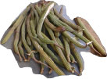
Inga pods.
- Where does Inga edulis originate?
Western Amazon region. of South America.
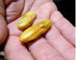

- Is it safe to use elsewhere?
Yes. It has been used widely throughout the tropics, mostly as a shade tree for coffee and cocoa. It is not native to Central

America, but has been successfully established there,
particularly in Honduras where many Inga alleys have been planted. Very few problems have been reported.
Inga seeds.

- How do you identify an Inga edulis?
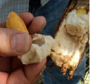
See Appendix 1 and/or ask a local botanist.

- Gather the seed, clean it, keep it moist
As soon as they are picked the seeds need to be cleaned of the sweet, white, edible pulp that surrounds them in the pod, otherwise they may rot. The empty pods can be used as
fertilizer. The seeds germinate quickly, sometimes even in the pods. They must not be allowed to dry out. The sooner they are planted out after picking the better, preferably in a few days, but within a fortnight at the very latest, but by then their fertility will have dropped. Under good conditions germination approaches 100%.
Cleaning Inga seeds.

- Possible treatment of seeds
Sometimes mycorrhizal inoculum is added, or the seeds can be soaked for 12 hours in a solution made with macerated Inga root nodules from a mature Inga tree and some soil from under it. This however is not always necessary, and much Inga has been planted without such treatment and is doing fine. Inga is not fussy as to which root nodule bacteria it forms a symbiotic relationship with.
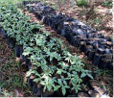;
Seeds/seedlings in black bogs
- Plant the seeds out in a nursery
Seeds/seedlings in black bogs
Use forest soil, as that is likely to contain all the microorganisms that are needed. Planting is usually done in black plastic bags of 15 cm diameter and 20 cm height. Use biodegradable bags, though even those cause some pollution if not properly disposed. Lay the seeds on their side and cover with 1 or 2 cm. soil.
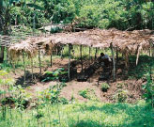
But if the seedlings are not going to be transported far consider bare root nursery (Appendix 2). This would be particularly useful for the farmers when they want to increase their plantings from their own seed tree. Saves on costs, and rubbish. But take care not to let the roots dry out during planting out. They can be transferred in a bucket of water or a damp cloth.
Farmer’s Inga nursery. Photo Antony Melville
Planting the seeds directly into the ground in the correct alley
cropping formation can also work if there is rain or the farmer is able to water them.

- How to construct a nursery
The seedlings need to be protected from the sun and heavy rain with either saran netting or palm leaves. The latter is a lot cheaper, and more readily available to farmers who want to grow their own. A wooden framework is constructed on wooden posts and covered with palm fronds.
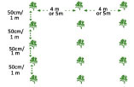

- Caring for the seeds and seedlings in the nursery
They need watered if the rain does not do it. The covering should be gradually decreased as the plants get ready for planting out until they are accustomed to full sun.

- When do you plant out?
In about 3 to 4 months, or when the seedlings are about 30 to 40 cm high. But if it happens that you cannot plant them out then do not despair. Many much older seedlings have been planted out successfully.
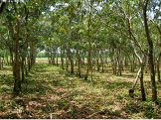

- Planting formation on level ground
The Inga trees are planted in rows, like hedges with 50 cm between each tree. The rows are planted with spaces of 4 m between them. Sometimes one can use a wider space between the trees, up to 1 m, and the space between them can also be extended to up to 5 m.
Photo and diagram of Inga alleys on level ground.

- Planting formation on sloping ground
The Inga are planted with the same spacing, but they have to follow the contours, otherwise the plantation will not be resistant to erosion. An easy to use device, the A-frame (see Appendix 3) can be used to do this. When the Inga is pruned later some of the pruned stems can be laid across the base of the trees to stop erosion. In time, as debris gets caught there, a terraced effect gets built up. If a wider spacing than 50 cm has been used something to stop erosion has to be planted between the Inga. Pineapples are suitable for this.
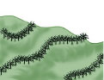

- Care of the young Inga after planting out
Diagram of planting on slopes.
Look after your Inga when it is small, and it will look after you when it is big. If it is dry some watering should be done, but that is likely to be practical only if the plantation is very small. Better to plant when there is rain. A circle of about 1 m should be weeded and kept clear round the base of the young trees. 1 hectare needs 5000 Inga when planted at 50 cm and 4 m spacings.
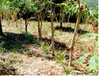

- When do you prune the Inga trees?
When the canopies have closed across the alleys – the 4 or 5 m spaces between the rows. The lack of light will have killed the weeds. The smaller prunings should be left to rot on the ground for about six weeks, though we have had good results with a shorter time. The larger branches make good firewood. The trees do not have to be pruned immediately when the canopies have closed. The crops will be planted about six weeks after pruning, so it is best to wait to prune until six weeks before you want to plant the crops – generally six weeks before rain is expected.
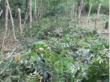
Pineapples between more widely spaced Inga on a slope. Photo Tiiu Miller

- How do you prune the Inga trees?
With a sharp tool so as to make a clean, slanted cut (so rain will run off and not rot the stump), to about chest high (1.5 m), leaving a leaf or two. Take care not to prune branches so close to the remaining stem that you risk tearing the stem. The bigger branches may be removed immediately or just before planting. The smaller branches and leaves are spread out in the alleys to fertilize the ground.
Recently pruned Inga alley

- Suppose that if you prune the Inga to chest high there are no branches low enough to leave any leaves, what do you do then?
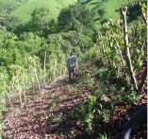
This is most likely to happen for the first pruning of a new plantation. Prune higher up, wait for branches and leaves to grow lower down, and then prune again to chest height.

- When and where do you plant crops?
You plant about six weeks after pruning, into the alleys not too close to the Inga. Time this to coincide with the best planting season. Generally 3 rows of crops such as maize are planted in the middle of each alley.
Pruned Inga on a slope with branches laid across tree bases to stop erosion. Photo FUPNAPIB
- What crops can you plant?
Pretty well anything that grows in the climate you have. Most farmers begin by planting basic crops like maize and beans. But many other crops, including cash crops, are grown.
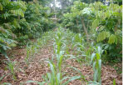
- What happens if the Inga grows fast and starts to shade the crops before they are ready to be harvested?
Do another light pruning

- When do you harvest the crops?
When they are ripe and ready for harvest.

- What happens to the Inga trees after you harvest the crops?
Young maize in an Inga alley with the Inga regrowing on both sides. The Inga has grown very fast and should be lightly pruned again to prevent shading the crop. Photo Gaston Bityo Delor.
They regrow; close their canopies again killing any weeds. Then they are ready for the next pruning.

- What happens to the mulch/prunings on the ground from earlier years in later years?
It accumulates, increasing fertility and the capacity of the mulch to retain moisture, making the plot drought resistant.
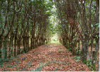
- How long does it take from planting the Inga to it being ready for pruning?
That depends on the soil, sun and rainfall. In good conditions about 18 months, in very poor conditions 3 years.

- Can you make any use of the land while the Inga is growing?
Yes. If the land is good you can grow a crop in the alley. If the land is not good you can still grow a crop in the alley, but you need to fertilize the soil with something like leaves from another legume. Don’t grow a tall crop like maize that would shade the young Inga. Low growing beans would be suitable. Beans are a legume and will help to improve the soil.
Mature Inga alley. Photo Tiiu Miller.
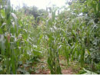

- How long can this system continue?
Many years. The same plot has been cultivated by this system for 12 years and was still going strong.

- What do you do if after several years the crops are not so good any more?
Mature maize in Inga alley
Add organic fertilizer. There is some evidence that pig manure might be good.

- What chemical inputs does the system need?
Generally none. In very poor soil an initial application of rock phosphate helps. The Inga is a legume that works in symbiosis with soil bacteria that form root nodules. These fix the nitrogen from the air, making it available to plants. Secondly it forms a symbiotic relationship with fungi (mycorrhiza) that live in its roots. These take up phosphorus, so it gets recycled and not washed away in the rain. Research found that loss of soil phosphorus was the main reason why the slash and burn plots lost their fertility so quickly
;

- Can Inga help with reforestation?
Yes. When it is hard to establish other forest trees, for example into land covered in tough, invasive grasses, Inga can be used to ‘capture’ the land. It is planted in a matrix at 4 m spacing, omitting one in every 4. When the Inga have shaded the ground forest trees are planted in the space that was left free. Some pruning of the Inga is likely to be needed until the forest trees get big.
Harvests. Photos Gaston Bityo Delor

- How do you plant a seed orchard for Inga seed?
The Inga trees are planted at wide spacing to allow them to grow into big trees. A mature Inga tree can produce 2000 seeds. In Honduras seed is typically produced in June and September, but this can vary in different places with different conditions and rainfall.

References and further reading,
www.rainforestsaver.org
Pennington, T.D. and Fernandes E.C.M. The Genus Inga: Utilization The Royal Botanic Gardens, Kew 1998

This system is based on the original work of Mike Hands

Contact information
contact@rainforestsaver.org www.rainforestsaver.org
Tel : +44(0)131 477 6970

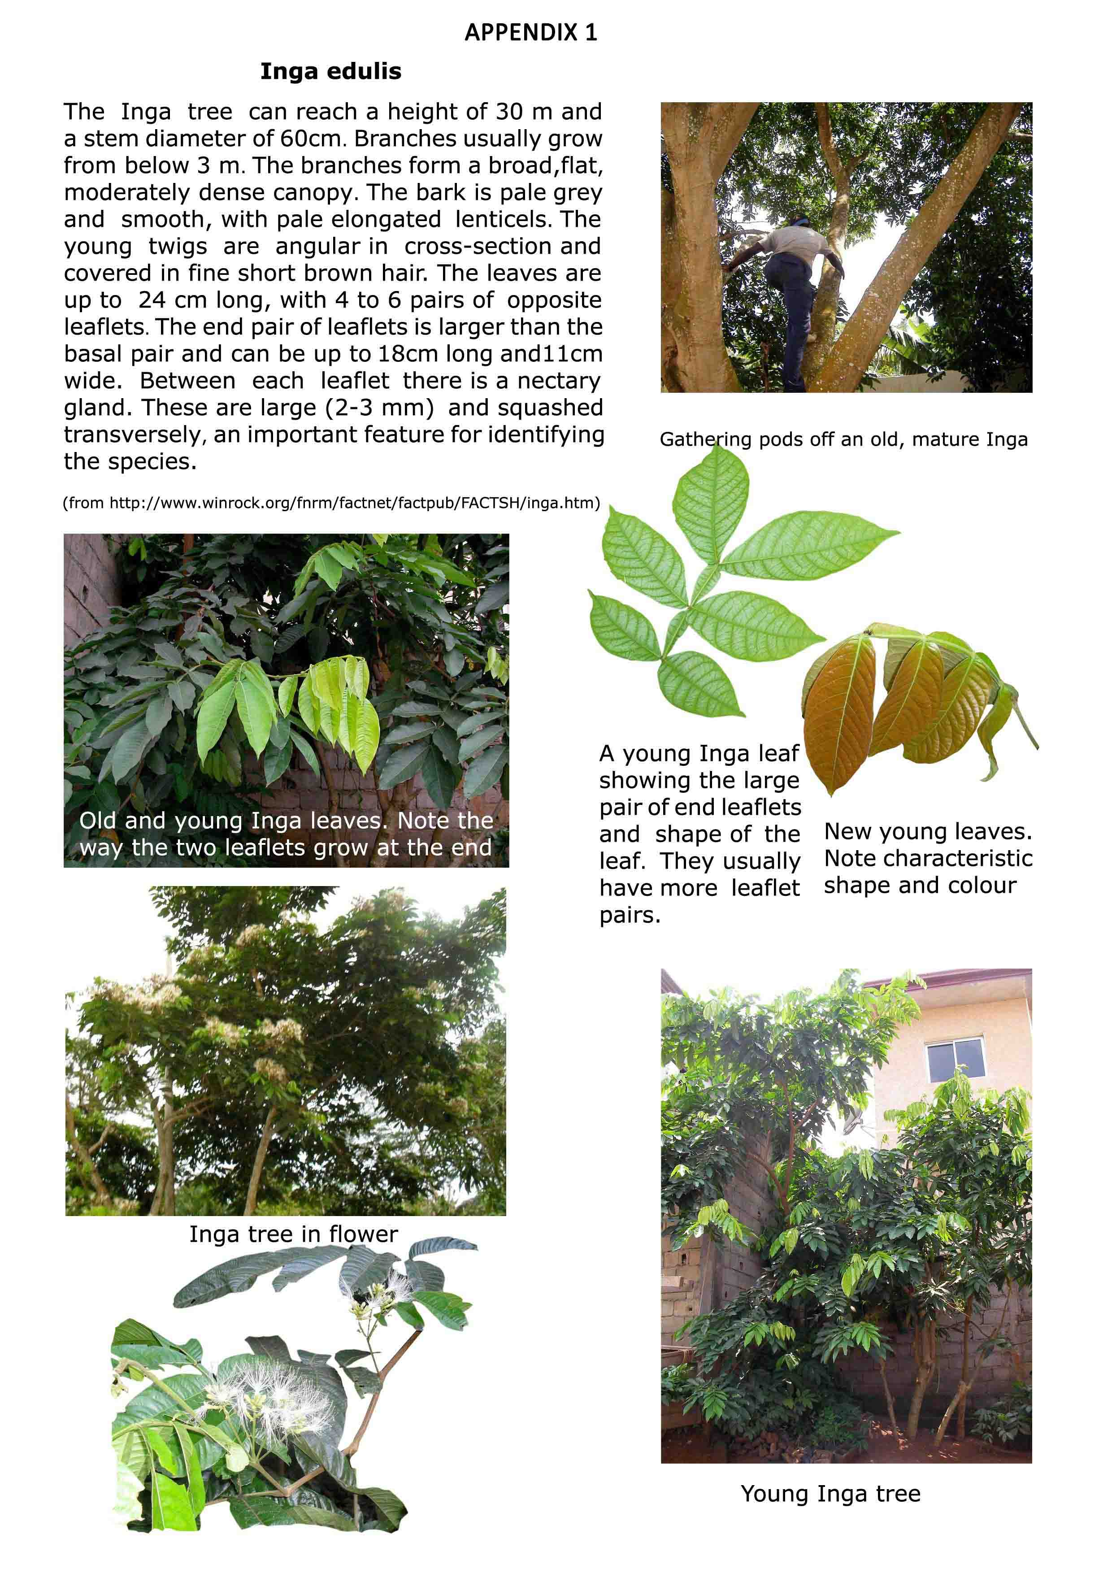
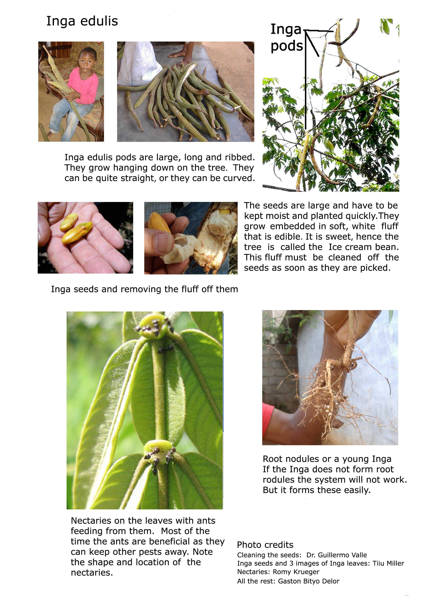

Appendix 2

From Trees for the Future Agroforestry manual.

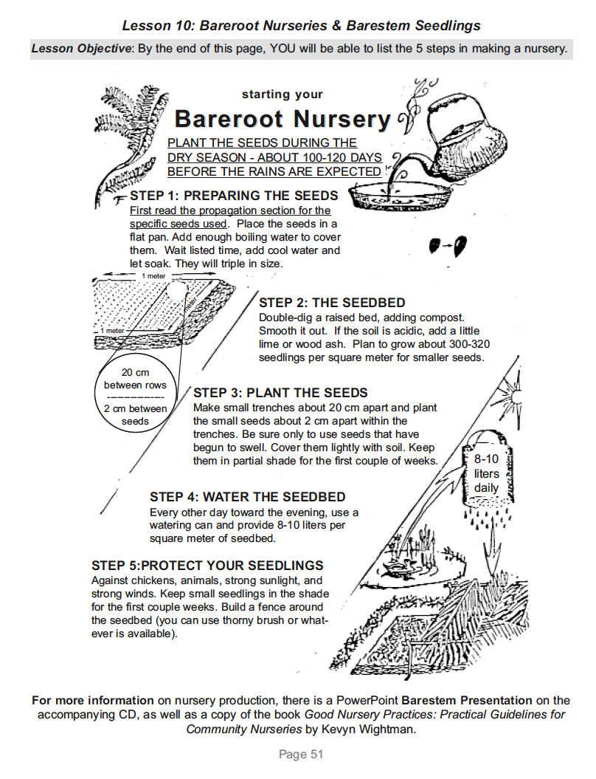
Note: Inga seeds are moist, they should not be soaked in boiling water, but kept from drying out. The instructions here are general, not specifically for Inga.

